St. Anne's Arts and Science College
Department of Computer Science

Team Members | Register No | Project Name | Overall Documentation
PRIYANKA.G | 222409485 | FitTrack AI - Personalized Fitness  Recommendations Powered by AI | All 8 Phases  (Complete Project  Documentation)
PUSHPA BIBIYA.J | 222409486
REVATHY.V | 222409487
RUBA LATHA.M | 222409488

FITTRACK AI
Personalized Fitness Recommendations Powered by AI
PROJECT DOCUMENTATION

AI-Powered Fitness Tracking and Recommendation Backend

Technology Stack: Node.js • Express.js • MongoDB • Mongoose • JWT • Google Gemini
Backend API Project Documentation

TABLE OF CONTENTS

- Project Description
- Scenario-Based Case Study
- Usage
- Project Outcome
- Software Requirements
- Hardware Requirements
- Project Architecture
- Overall Architecture Components
- Component Definitions
- Entity Relationship Design
- Key Features
- Roles and Responsibilities 13. User Flow
- MVC Architecture Pattern
- Project Setup and Configuration
- Project Folder Structure
- Environment Variables
- Backend Development
- Database Configuration
- MongoDB Configuration
- Mongoose
- MongoDB Connection
- Mongoose Schemas
- User Schema
- Workout Schema
- Project Execution and API Testing
- API Endpoints
- Testing Evidence and Media 29. Future Enhancements

1. PROJECT DESCRIPTION
FitTrack AI is a secure, AI-powered fitness tracking backend designed to manage workout records and provide personalized fitness recommendations. The application is developed using Node.js, Express.js, MongoDB, and Mongoose, with Google Gemini integration for AI-powered guidance.
The system provides RESTful APIs for user authentication, workout management, workout searching, personalized recommendations, and fitness insights. The backend follows a modular MVC-based architecture to improve maintainability, security, scalability, and future extension.
- JWT-based authentication protects secured APIs.
- Passwords are securely hashed using bcrypt.js before storage.
- MongoDB provides persistent storage for users and workout records.
- Google Gemini generates personalized fitness recommendations and insights.
- JSON-based REST responses can be consumed by web, mobile, or API-testing clients.
- Input validation, centralized error handling, route protection, and service modules improve reliability.

2. SCENARIO-BASED CASE STUDY

2.1 Background
Rahul is a fitness enthusiast who manually records workouts in notebooks or spreadsheets. As the number of workout records increases, maintaining history, monitoring progress, and obtaining personalized guidance becomes difficult.

2.2 Problem Identification
- Difficulty maintaining a centralized workout record.
- Possible inaccuracies caused by manual tracking.
- Lack of secure user authentication in a simple manual system.
- Difficulty searching and retrieving previous workout records.
- No personalized workout recommendations.
- No automated fitness-performance insights.
- Manual effort required for tracking duration and calorie-related information.

2.3 Proposed Solution
FitTrack AI provides a centralized backend where users can register and log in securely, create and manage workout records through REST APIs, search workout history, and receive AI-powered recommendations and fitness insights through Google Gemini.

3. USAGE

3.1 User Usage
- Register using the authentication API.
- Log in using email and password.
- Receive a JWT token after successful authentication.
- Create, view, update, and delete workout records.
- Retrieve individual workout records by ID.
- Search workouts by name, category, or date.
- Request AI-powered workout recommendations.
- Request AI-generated fitness insights.

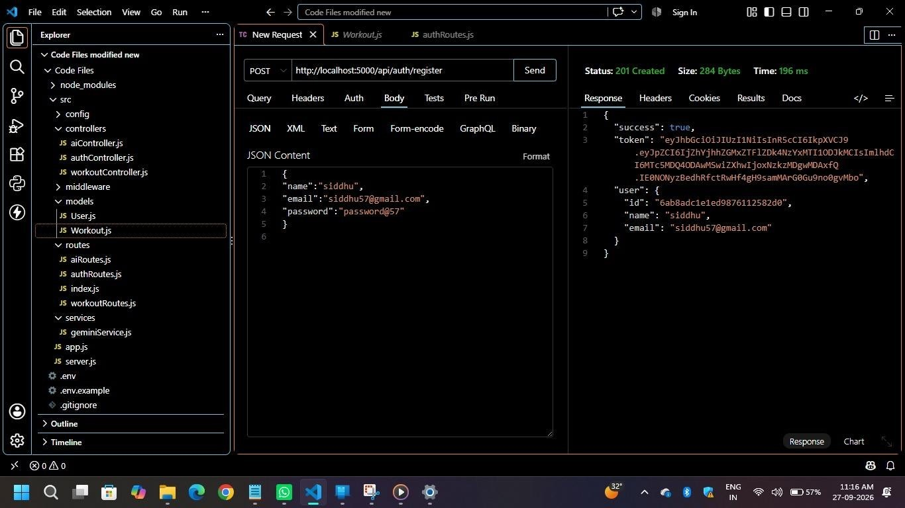

Register using the authentication API.

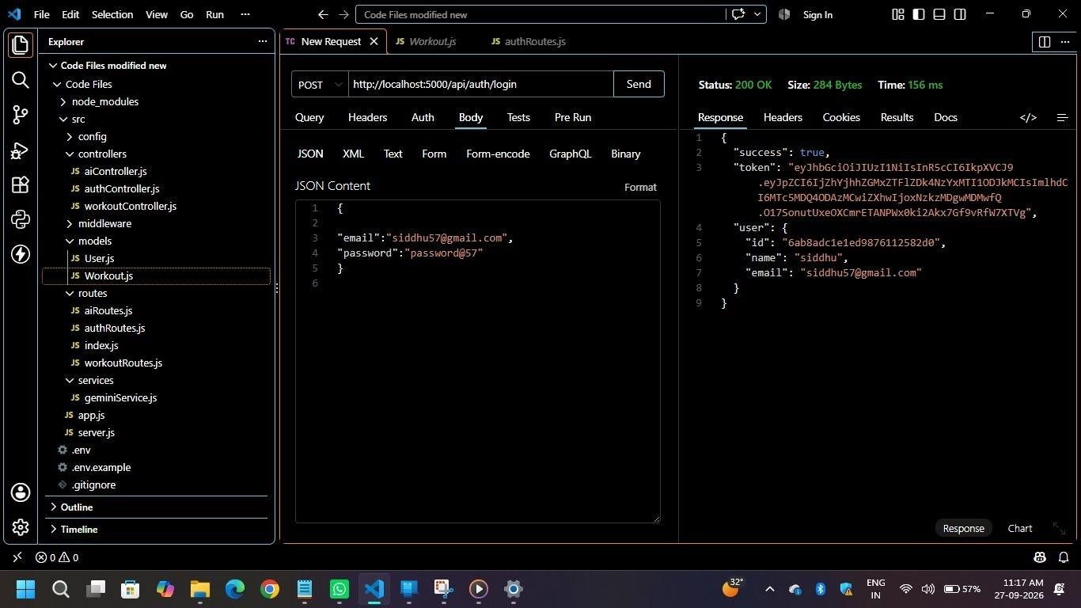

Log in using email and password

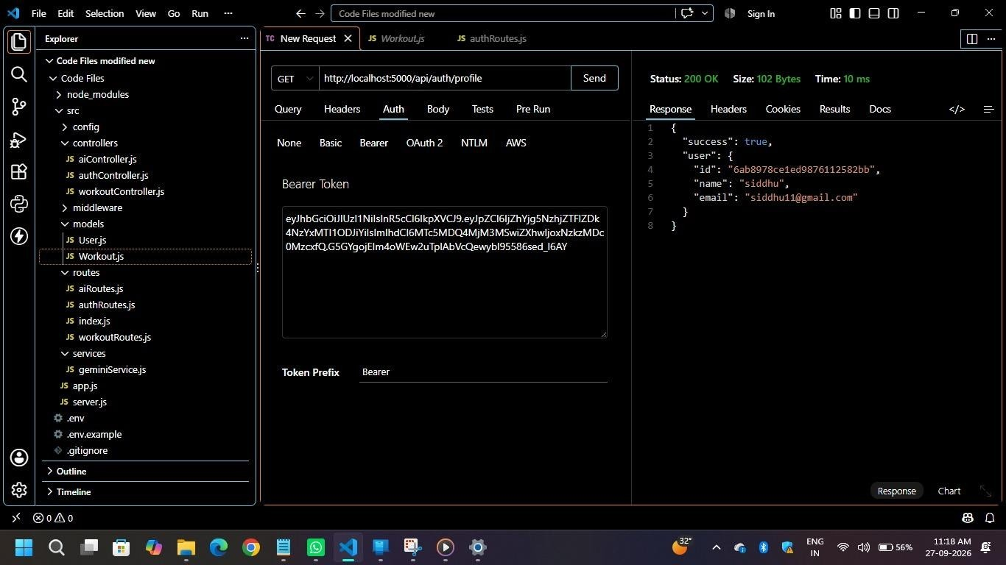

Get Profile
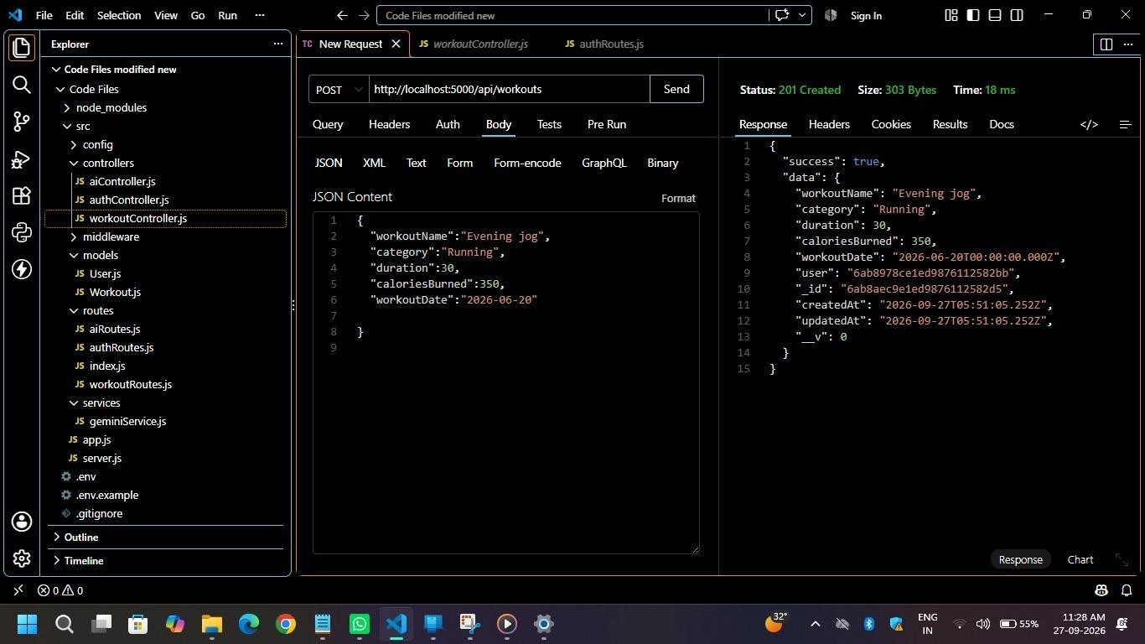

Add Workouts
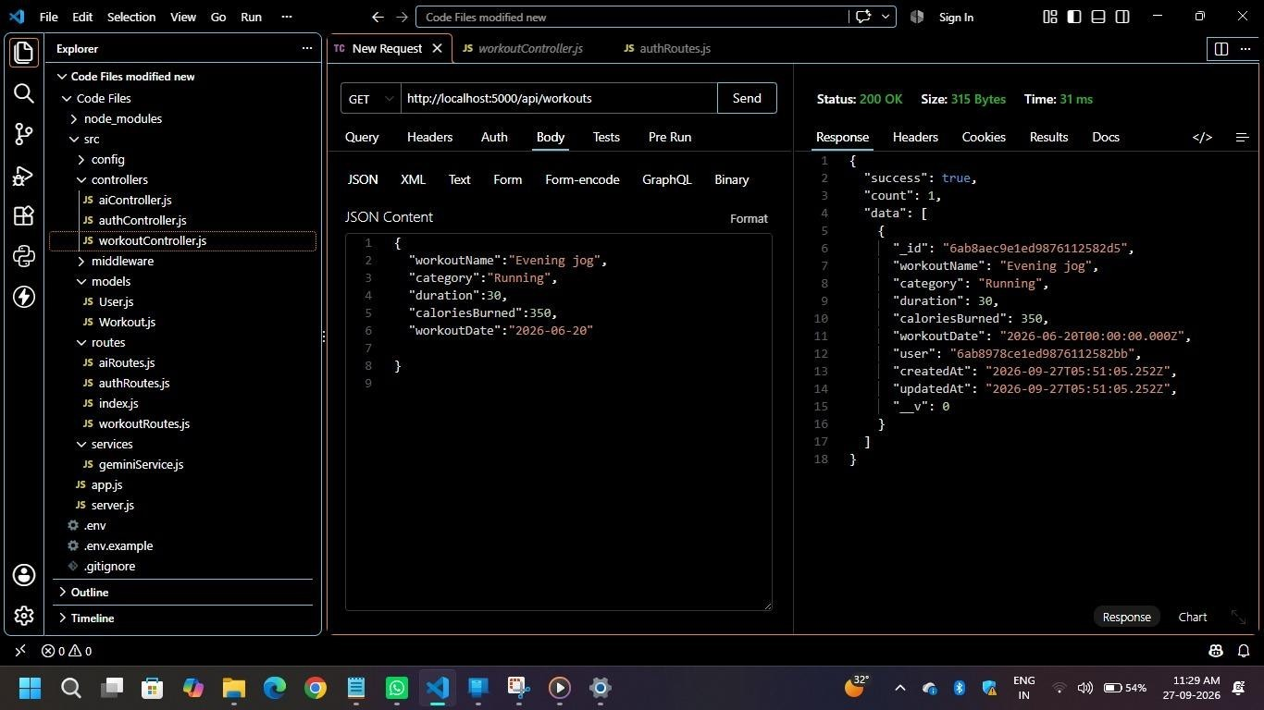

Get All Workouts
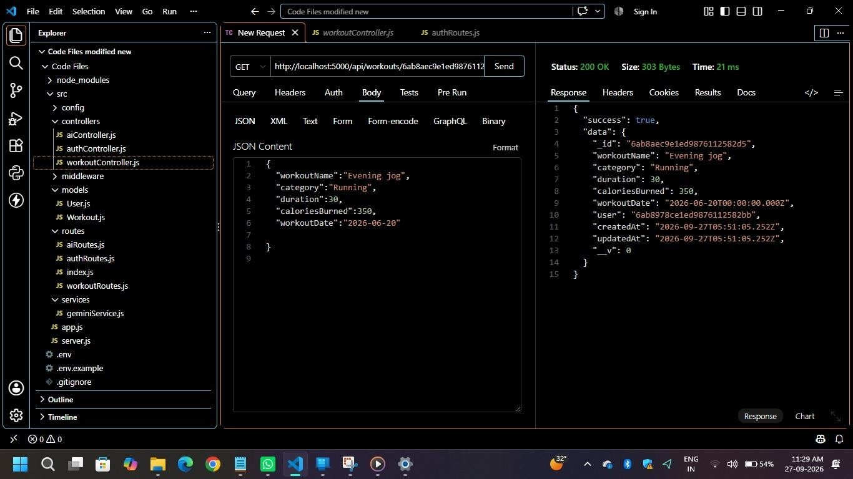
Workout Id
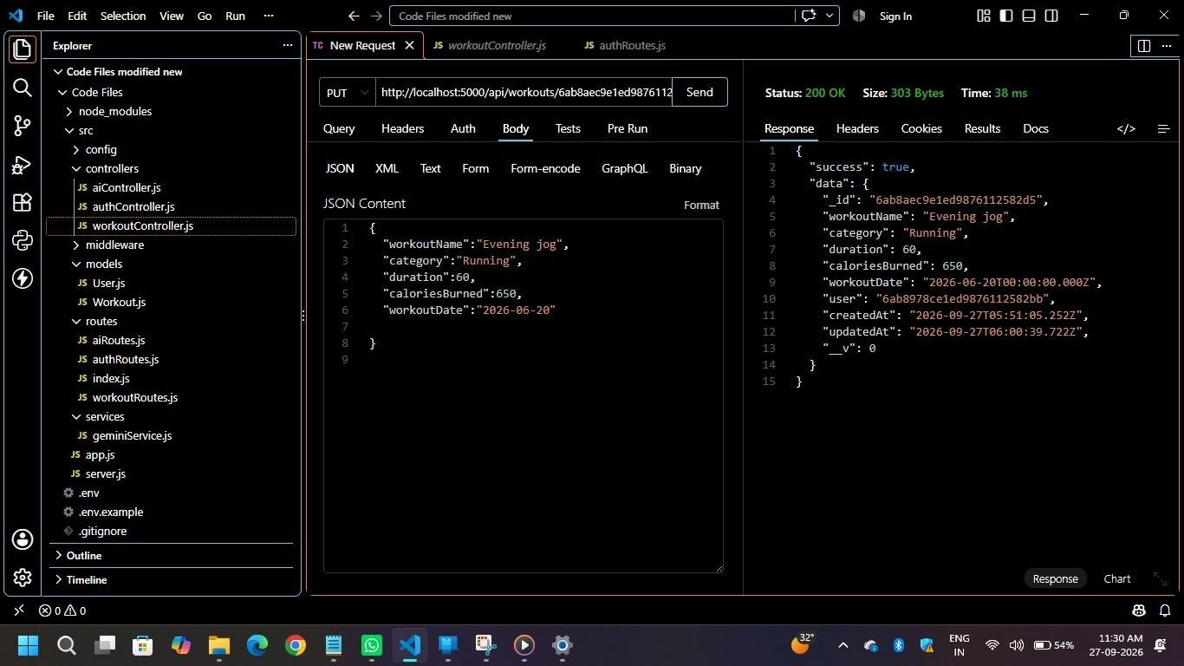

Update The Workouts
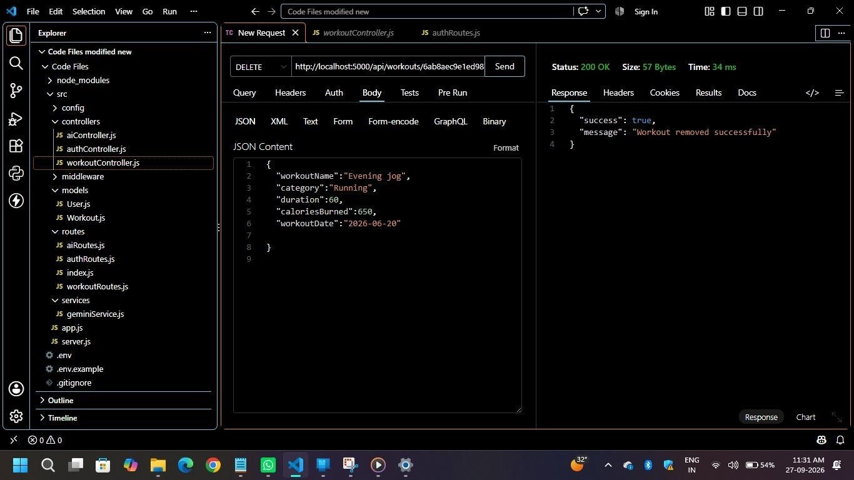

Delete The Workouts

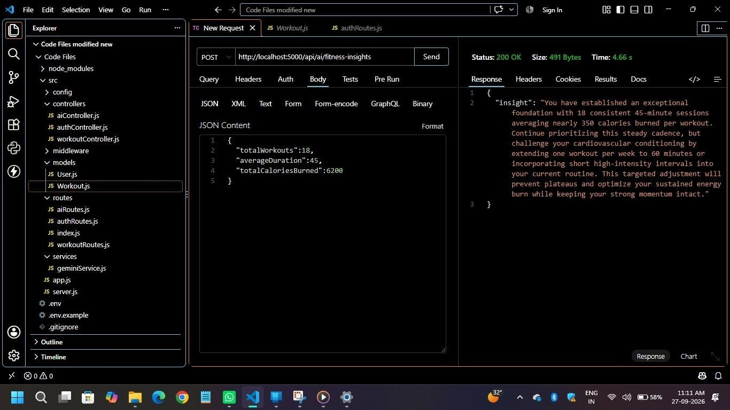

Request AI-generated fitness insights.
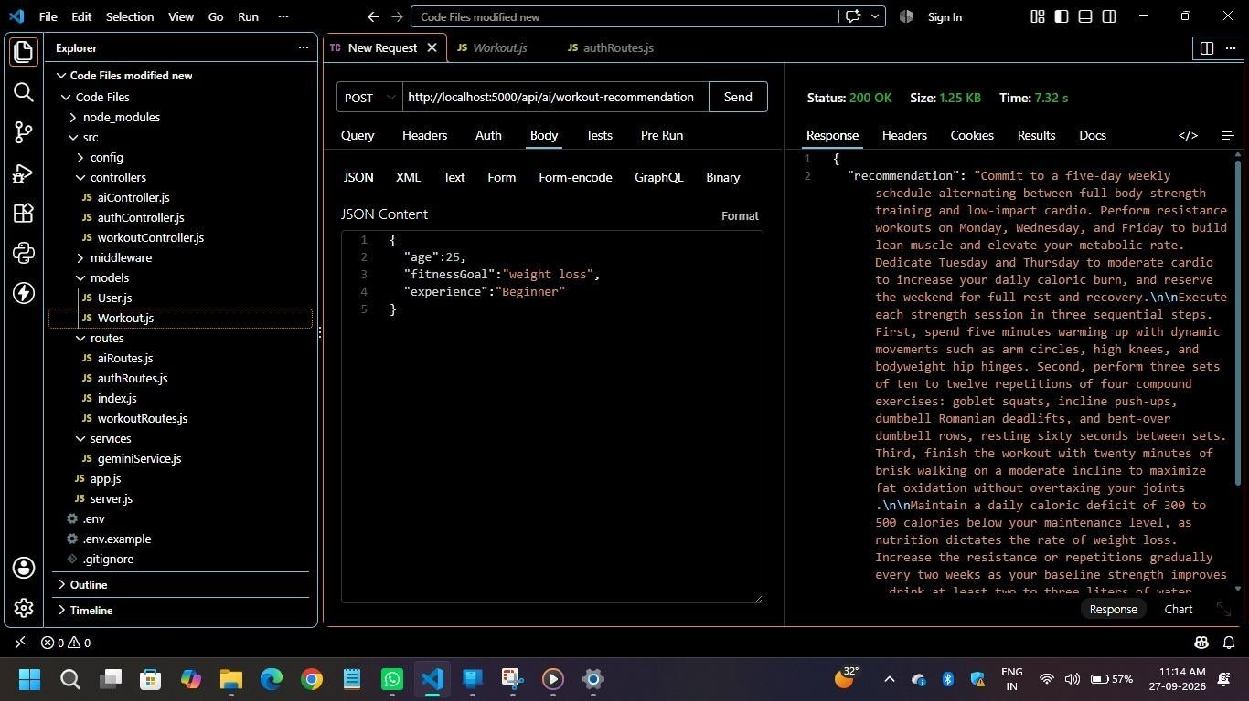

Request AI-powered workout recommendations.

3.2 AI Usage
Google Gemini is accessed through a dedicated service layer. The recommendation module uses:
Input | AI Output
Age | Personalized workout plan
Fitness Goal | Weekly workout suggestions
Experience Level | Beginner / Intermediate / Advanced recommendations
User context | Motivational guidance and safety tips

Fitness insight generation uses workout statistics such as:
- Total workouts
- Average workout duration
- Total calories burned
The AI uses these statistics to generate personalized fitness insights and improvement suggestions.

4. PROJECT OUTCOME
- Reduces manual fitness record-keeping effort.
- Provides secure and organized workout information.
- Offers personalized AI-based fitness guidance.
- Uses a modular MVC architecture for easier maintenance.

Provides a foundation for future features such as nutrition tracking, BMI calculation, wearable integration, reminders, and analytics dashboards.

5. SOFTWARE REQUIREMENTS
Software / Tool | Requirement
Operating System | Windows 10/11, macOS, or Linux
Node.js | Version 16 or later
Package Manager | npm
Backend Framework | Express.js
Database | MongoDB
API Testing | Postman or Thunder Client
Code Editor | Visual Studio Code

6. HARDWARE REQUIREMENTS
Component | Minimum / Recommended Requirement
Processor | Intel Core i5 8th Gen or AMD Ryzen 5 equivalent
RAM | 8 GB minimum; 16 GB recommended
Storage | At least 1 GB available for project requirements

7. PROJECT ARCHITECTURE
FitTrack AI follows a layered MVC-oriented backend architecture. Routing, controllers, business services, database operations, authentication middleware, and AI integration are separated into dedicated modules.
Typical request flow:
HTTP Request → Express Server → Route → JWT Middleware → Controller → Service / Database → JSON Response
This separation improves modularity, security, maintainability, scalability, and organization.

8. OVERALL ARCHITECTURE COMPONENTS
No. | Component | Responsibility
1 | Client Application | React application, mobile client, Postman, or Thunder Client that sends API requests.
2 | Express Server | Main backend server and request gateway.
3 | API Routes | Defines authentication, workout, and AI endpoints.
4 | Authentication Middleware | Verifies JWT tokens and protects private routes.
5 | Controllers | Handle requests, validation, business flow, and responses.
6 | Services | Contain reusable business and integration logic.
7 | Google Gemini AI Service | Prepares prompts and communicates with Gemini for recommendations and insights.
8 | MongoDB Database | Stores persistent user and workout data.
9 | Mongoose Models | Defines schemas, validation, relationships, and database operations.

9. COMPONENT DEFINITIONS

9.1 Client Layer
The client layer may be a React application, mobile application, Postman, or Thunder Client.
- Sends HTTP requests to backend APIs.
- Receives and displays JSON responses.
- Stores the JWT token after login where appropriate.
- Calls workout and AI APIs.
- Displays success and error messages.
Major API groups: Authentication, Workout Management, AI Recommendation, and AI Fitness Insight.

9.2 Express Server Gateway
- Starts the backend server.
- Parses JSON requests.
- Handles CORS configuration.
- Registers routes and middleware.
- Provides centralized error handling.
Request flow: HTTP Request → Request Validation → Routes → Controller → Response.

9.3 Authentication Middleware
JWT authentication protects private resources.
- Reads the Authorization header.
- Extracts the JWT token.
- Verifies the token signature and validity.
- Decodes the authenticated user information.
- Attaches user information to the request.
- Rejects unauthorized requests.

9.4 Route Layer
Route Group | Main Operations
Authentication | Register, Login, Profile
Workout | Add, Get All, Search, Get by ID, Update, Delete
AI | Workout Recommendation, Fitness Insights

9.5 Controller Layer
Controllers coordinate request validation, business logic, service/database operations, and JSON responses.
- Authentication Controller – registration, login, and profile.
- Workout Controller – create, retrieve, update, delete, and search.
- AI Controller – sends prompts to Gemini and returns AI-generated responses.

9.6 Service Layer
- Gemini AI Service – prepares prompts, communicates with Gemini, and formats responses.
JWT Service – creates tokens, manages expiry, and verifies identity.
- Password Service – hashes passwords and compares passwords during login.

9.7 Database Layer
MongoDB provides persistent storage and Mongoose acts as the Object Data Modeling layer.
- Users collection stores authentication and profile information.
- Workouts collection stores workout records.
- Mongoose provides schema definition, validation, references, and database methods.

10. ENTITY RELATIONSHIP DESIGN

10.1 User Entity
Field | Type | Description / Constraint
_id | ObjectId | Primary Key
name | String | User name; mandatory
email | String | Unique email address
password | String | Encrypted / hashed password
createdAt | Date | Record creation time
updatedAt | Date | Last update time

10.2 Workout Entity
Field | Type | Description / Constraint
_id | ObjectId | Primary Key
user | ObjectId | Reference to User
workoutName | String | Workout name; mandatory
category | String | Workout category; mandatory
duration | Number | Duration in minutes; must be greater than zero
caloriesBurned | Number | Calories burned; minimum value 0
workoutDate | Date | Workout date
createdAt | Date | Creation timestamp
updatedAt | Date | Last update timestamp

10.3 Relationship
The relationship between User and Workout is one-to-many. One user can have multiple workout records, while each workout belongs to one user. The relationship is implemented using the user reference field in the Workout schema.
Example: John Doe → Morning Running, Evening Jogging, Upper Body Strength, Cycling Session.

11. KEY FEATURES
11.1 Secure Authentication
JWT authentication, registration, login, password hashing, token generation, and protected APIs.
11.2 Workout Management
Create, view, update, and delete workout records linked to the authenticated user.
11.3 Workout Search
Search workouts using name, category, or date.
11.4 Google Gemini Integration
Generates weekly plans, suggested exercises, training tips, and safety recommendations from user inputs.
11.5 AI Fitness Insights
Generates performance analysis, improvement suggestions, motivational advice, and progress summaries.

11.6 Centralized Error Handling
Returns structured JSON errors for invalid credentials, missing tokens, validation failures, database errors, and internal errors.
11.7 RESTful API Design
Uses GET, POST, PUT, and DELETE methods with JSON responses.
11.8 Modular Architecture
Separates models, controllers, routes, middleware, services, and configuration.

12. ROLES AND RESPONSIBILITIES
Primary role: Authenticated User
Permission | Available
Register | Yes
Login | Yes
View Profile | Yes
Add Workout | Yes
Get Workouts | Yes
Search Workouts | Yes
Update Workout | Yes
Delete Workout | Yes
AI Recommendation | Yes
Fitness Insights | Yes

The authenticated user is responsible for maintaining their workout information and requesting AI-powered guidance.

13. USER FLOW
Typical user flow:
Register → Login → Receive JWT → Access Protected APIs → Manage Workouts → Request AI Guidance → View Response

14. MVC ARCHITECTURE PATTERN

14.1 Model Layer
The Model layer uses Mongoose schemas and MongoDB collections.
Defines database schemas.
- Validates data.
- Provides CRUD operations.
- Maps application objects to MongoDB collections.

14.2 View Layer
The backend does not use traditional server-side UI templates. API consumers such as React, mobile applications, Postman, or Thunder Client act as the presentation/client layer. They send HTTP requests and receive JSON responses.

14.3 Controller Layer
The Controller layer connects client requests with models and services. It handles request validation, business flow, database interaction, AI service calls, and response generation. Separation of responsibilities improves testing, maintenance, and extension.

15. PROJECT SETUP AND CONFIGURATION
The backend is organized as a Node.js and Express.js project with MongoDB and Google Gemini integration.

15.1 Creating the Project Folder
- Create a project folder named AI-FitTrack-API.
- Open the folder in Visual Studio Code.
- Create the server-side project structure.
- Initialize the Node.js project using npm init -y.
- Install the required dependencies.
Main dependency installation:
npm install express mongoose dotenv bcryptjs jsonwebtoken cors npm install --save-dev nodemon

16. PROJECT FOLDER STRUCTURE
AI-FitTrack-API/
│
├── client/
│
└── server/
├── config/
├── controllers/
├── middleware/
├── models/
├── routes/
├── services/
├── .env
├── package.json
└── server.js

17. ENVIRONMENT VARIABLES
PORT=5000
MONGO_URI=mongodb://localhost:27017/aifittrack
JWT_SECRET=your_secret_key
GEMINI_API_KEY=your_google_gemini_api_key

Environment variables keep sensitive configuration values outside the main source code. Actual secret keys should not be exposed in screenshots or public repositories.

18. BACKEND DEVELOPMENT
The backend provides REST APIs for authenticated workout management and Google Gemini-powered fitness guidance. The major modules include server configuration, database configuration, authentication, workout management, AI recommendations, middleware, and centralized error handling.

19. DATABASE CONFIGURATION
MongoDB is used as the primary NoSQL database. It stores user authentication information and workout records. Mongoose provides schema validation, middleware, relationships, and CRUD support.

20. MONGODB CONFIGURATION
The application uses MongoDB collections for persistent storage.
Collection | Purpose
Users | Stores user account and authentication-related information.
Workouts | Stores workout records linked to authenticated users.

MongoDB stores records as BSON documents and supports flexible document-based data management.

21. MONGOOSE
Mongoose provides an interface between Node.js and MongoDB. It is used to define schemas, validate data, execute database operations, and manage model relationships.
- Schema definitions
- Validation
- Database methods
- Middleware
- Model-based CRUD operations

22. MONGODB CONNECTION
The database connection is maintained in a dedicated configuration module such as config/db.js. The module establishes the MongoDB connection, handles connection errors, and exports the reusable connection logic.
- Centralized database configuration.
- Reusable connection module.
- Clear connection status and error handling.
- Simplified database management.

23. MONGOOSE SCHEMAS
Mongoose schemas define the structure and validation rules for User and Workout data. They also support references and timestamps.

24. USER SCHEMA
The User schema stores authentication and basic user information.
- Name must be provided.
- Email must be unique.
- Password is mandatory.
- Password is hashed using bcrypt before saving.
Module | Method | Endpoint | Purpose
Auth | POST | /api/auth/register | Register a new user
Auth | POST | /api/auth/login | Authenticate user and receive
- Created and updated timestamps are maintained.
- The schema supports secure authentication and JWT-based authorization.

25. WORKOUT SCHEMA
The Workout schema stores workout information created by authenticated users. Each workout is associated with a User through an ObjectId reference.
Field | Validation / Purpose
workoutName | Mandatory workout name.
category | Mandatory category; supported examples include Cardio, Strength Training, Yoga, Running, Cycling, and Walking.
duration | Must be greater than zero.
caloriesBurned | Minimum value is 0.
workoutDate | Stores the date of the workout.
user | References the User document.
timestamps | Stores createdAt and updatedAt automatically.

26. PROJECT EXECUTION AND API TESTING
After completing configuration and development, the server can be started and the REST APIs can be tested using Postman or Thunder Client.

27. API ENDPOINTS
 |  |  | JWT
Auth | GET | /api/auth/profile | Get authenticated user profile
Workout | POST | /api/workouts/ | Create a workout
Workout | GET | /api/workouts/ | Get workouts
Workout | GET | /api/workouts/:id | Get workout by ID
Workout | PUT | /api/workouts/:id | Update workout
Workout | DELETE | /api/workouts/:id | Delete workout
AI | POST | /api/workout-recommendation | Generate workout recommendation
AI | POST | /api/fitness-insights | Generate fitness insights

28. TESTING EVIDENCE AND MEDIA
Screenshots and videos should be inserted as evidence of implementation and API testing. Each screenshot should have a short caption and be centered. Avoid stretching screenshots; preserve aspect ratio.
Available project media links:
Demo / Backend Development
Video: https://drive.google.com/file/d/1HtKapGMJfpXX0RTs4a97txQYXh_a2SJm/view?usp=drivesdk
API Testing Video https://drive.google.com/file/d/16qFrrqSGHthvvi6P5r5F0ME1VRX3_sl8/view?usp=drivesdk

29. FUTURE ENHANCEMENTS
- Nutrition and diet tracking.
- BMI and body-composition related features.
- Integration with wearable fitness devices.
- Workout reminders and notifications.
- Analytics dashboards and progress visualization.
- Additional AI-powered personalization features.

